**Railway Management System**

**PROBLEM STATMENT:**

**To enhance operational efficiency and passenger experience, create a railway management database to track schedules, maintenance, and passenger information. This will streamline operations, improve safety, and provide personalized services.**

Develop a Railway Management System for efficient and organized management of trains, passengers, tracks, stations, schedules, and routes.

**1.Train Management**:

Maintain a record of all trains, including their names, types, and unique identifiers. Track the usage of tracks by different trains and manage their assignment.

**2.Passenger Management**:

Register passengers with relevant personal information, including names, gender, age, and contact details. Allocate seats and coaches for passengers on trains.

**3.Track Management**:

Keep track of available railway tracks, including their lengths.

**4.Station Management**:

Maintain information about railway stations, including names and locations.

**5.Schedule Management**:

Create and manage schedules for trains, specifying the source and destination stations and departure and arrival times.

**6.Route Management**:

Define routes, specifying the sequence of stations and the total number of stops.

**INTRODUCTION:**

Our Railway Management System is a comprehensive solution designed to ensure efficient and organized management of trains, passengers, tracks, stations, schedules, and routes. It provides a seamless interface for maintaining records of trains and passengers, tracking the usage of railway tracks, managing station information, creating train schedules, and defining routes. This system aims to enhance the overall railway management process by ensuring accuracy, improving operational efficiency, and providing a better travel experience for passengers. It’s a one-stop solution for all railway management needs.

**ER DIAGRAM:**  
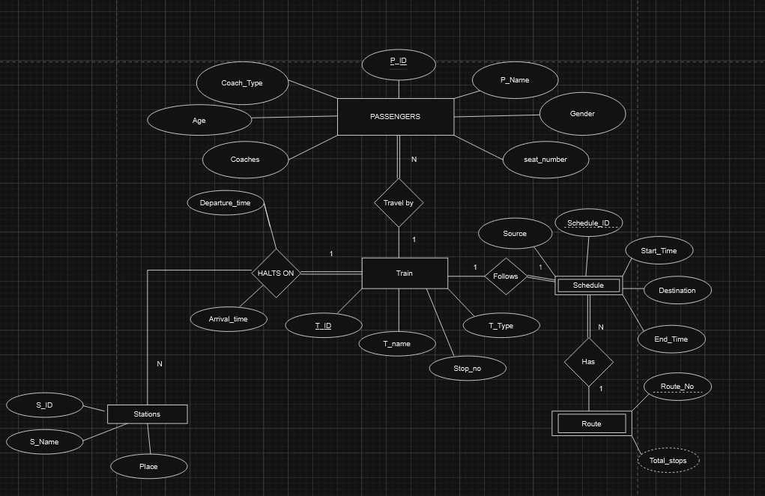

**PHYSICAL SCHEMA:**

